STUDENT PERFORMANCE ANALYTICS SYSTEM
1. Project Objective
The objective of this project is to develop a Python-based Student Performance Analytics System to analyse student marks, calculate total and average marks, assign grades, identify pass and fail students, and evaluate subject-wise performance.
2. Technologies Used
- Python
- Pandas
- NumPy
- Google Colab
- Microsoft Excel and CSV
3. Dataset Description
The dataset contains 20 student records. It includes Student ID, Name, Department, Physics marks, Chemistry marks, Science marks and Attendance.
The dataset was created using Microsoft Excel and saved as a CSV file for processing in Python.
4. Implementation
First, the student dataset was loaded into Python using the Pandas library. The marks obtained in Physics, Chemistry and Science were used to calculate each student's total and average marks.
Functions and conditional statements were used to assign grades and identify pass or fail students. A student was considered to have failed if their marks were below 40 in any one of the three subjects.
NumPy was used for numerical calculations, and Pandas was used to organize and analyse the student data.
The program also calculated the class average, subject-wise averages, highest and lowest marks, and identified the top-performing student.
Python program:
import pandas as pd
import numpy as np
# Load student data
df = pd.read_csv('/content/student_marks_datasheet(1).csv')
df.columns = df.columns.str.strip()
subjects = ['Physics', 'Chemistry', 'Science']
# Calculate total and average marks
df['Total'] = df[subjects].sum(axis=1)
df['Average'] = df[subjects].mean(axis=1)
# Assign grade
def grade(avg):
if avg >= 90:
return 'A+'
elif avg >= 80:
return 'A'
elif avg >= 70:
return 'B'
elif avg >= 60:
return 'C'
elif avg >= 50:
return 'D'
else:
return 'E'
# Check pass or fail
def check_result(row):
for subject in subjects:
if row[subject] < 40:
return 'Fail'
return 'Pass'
df['Grade'] = df['Average'].apply(grade)
df['Result'] = df.apply(check_result, axis=1)
df.loc[df['Result'] == 'Fail', 'Grade'] = 'F'
# Display student report
print("STUDENT PERFORMANCE REPORT")
print(df.to_string(index=False))
# Class analysis
print("\nCLASS ANALYSIS")
print("Total students:", len(df))
print("Passed:", (df['Result'] == 'Pass').sum())
print("Failed:", (df['Result'] == 'Fail').sum())
print("Class average:", round(np.mean(df['Average']), 2))
# Subject-wise analysis
print("\nSUBJECT-WISE PERFORMANCE")
for subject in subjects:
print(subject, "Average:", round(np.mean(df[subject]), 2))
print("Highest marks:", df[subject].max())
print("Lowest marks:", df[subject].min())
best_subject = max(subjects, key=lambda s: df[s].mean())
print("Best-performing subject:", best_subject)
# Top and lowest performers
print("\nTOP-PERFORMING STUDENT(S)")
print(df.loc[df['Average'] == df['Average'].max(),
['Name', 'Average', 'Grade']].to_string(index=False))
print("\nLOWEST-PERFORMING STUDENT(S)")
print(df.loc[df['Average'] == df['Average'].min(),
['Name', 'Average', 'Grade']].to_string(index=False))
# Save results
df.to_csv('/content/student_performance_results.csv', index=False)
print("\nResults saved successfully.")
5. Key Features
- Displays student records and marks.
- Calculates total and average marks.
- Assigns grades based on the defined grading rules.
- Identifies pass and fail students.
- Calculates subject-wise averages and highest and lowest marks.
- Identifies top-performing students.
- Saves the analysed results into a new CSV file.
6. Output and Results
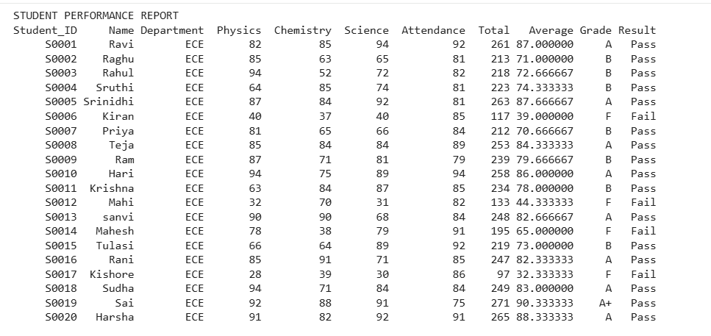
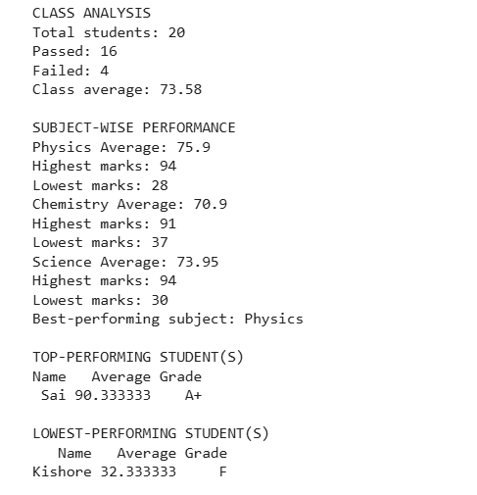
7. Challenges and Learning
During this project, I learned how to load CSV files into Python, use Pandas to organize data, perform numerical calculations using NumPy, and apply functions and conditional statements to analyse student performance.
I also learned how to identify errors in Python code and save the final analysed data into a CSV file.
8. Final Outcome
The Student Performance Analytics System successfully analysed student marks and generated meaningful performance results. It helped demonstrate how Python, Pandas and NumPy can be used to process and analyse educational data.

